NUWA-SP Localization of digital spectrum multi channel

INTRO：
The NUWA-SP digital spectrum resolution multichannel produced by Jiechuang Nuclear Instrument (Beijing) Technology Co., Ltd. is a set of 100% domestic tube base integration system, mainly used for NaI, LaBr3, BGO and other scintillation detector energy spectrum reading, waveform full sampling technology directly digitizing the forward signal, internal integrated high voltage control, zero adjustment, etc. Gain adjustment and temperature acquisition, the spectral data obtained can complete the spectral decomposition function in multiple channels.

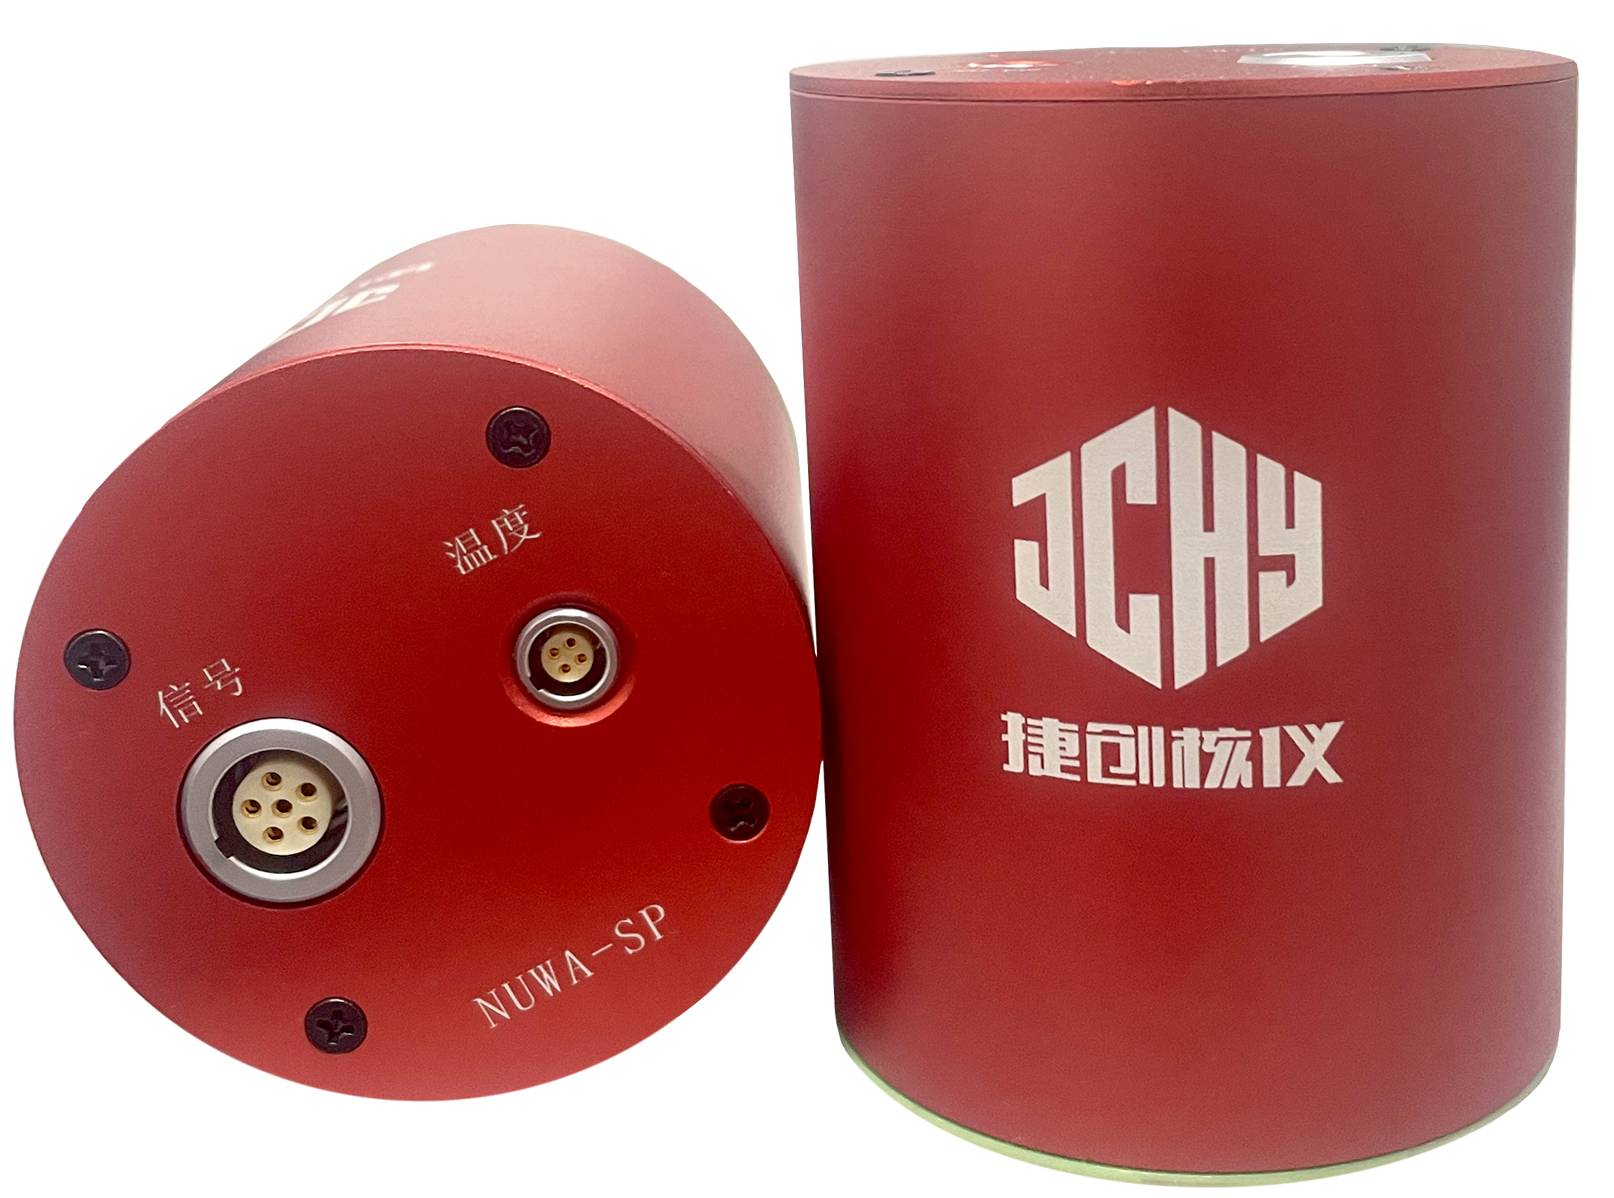

Hardware features
- 3 grades coarse gain software is adjustable, 0.5~1.5 fine gain software is adjustable;
- conversion gain: 1024,2048,4096 channels software adjustable;
- counting pass rate: 200Kcps;
- Long-term operation is stable and reliable, 72-hour zero drift is less than 1 channel, 72-hour gain instability is less than two-thousandth;
- zero temperature coefficient: less than 0.2 channel /℃; Gain temperature coefficient: less than 0.1% / ℃;
- Power supply: +12V, power consumption: less than 2W;
- two sets of 485 output, one for standard Modbus RTU output, one for PC debugging work,
- two 485 can work at the same time, convenient for user debugging and comparison;
- built-in full digital peak stabilization program, specify a specific energy peak for digital peak stabilization. For 24 consecutive hours, the peak shift ≤1 channel;
- Energy scale and efficiency scale can be performed, and key parameters can be stored offline;
- can be used for digital spectrum resolution, can specify the energy region of interest to calculate the net peak area and nuclide identification, can give the net peak area or increment information;

